Kubernetes Task-1
- Setup Minikube in your local machine.
  - Install docker in windows
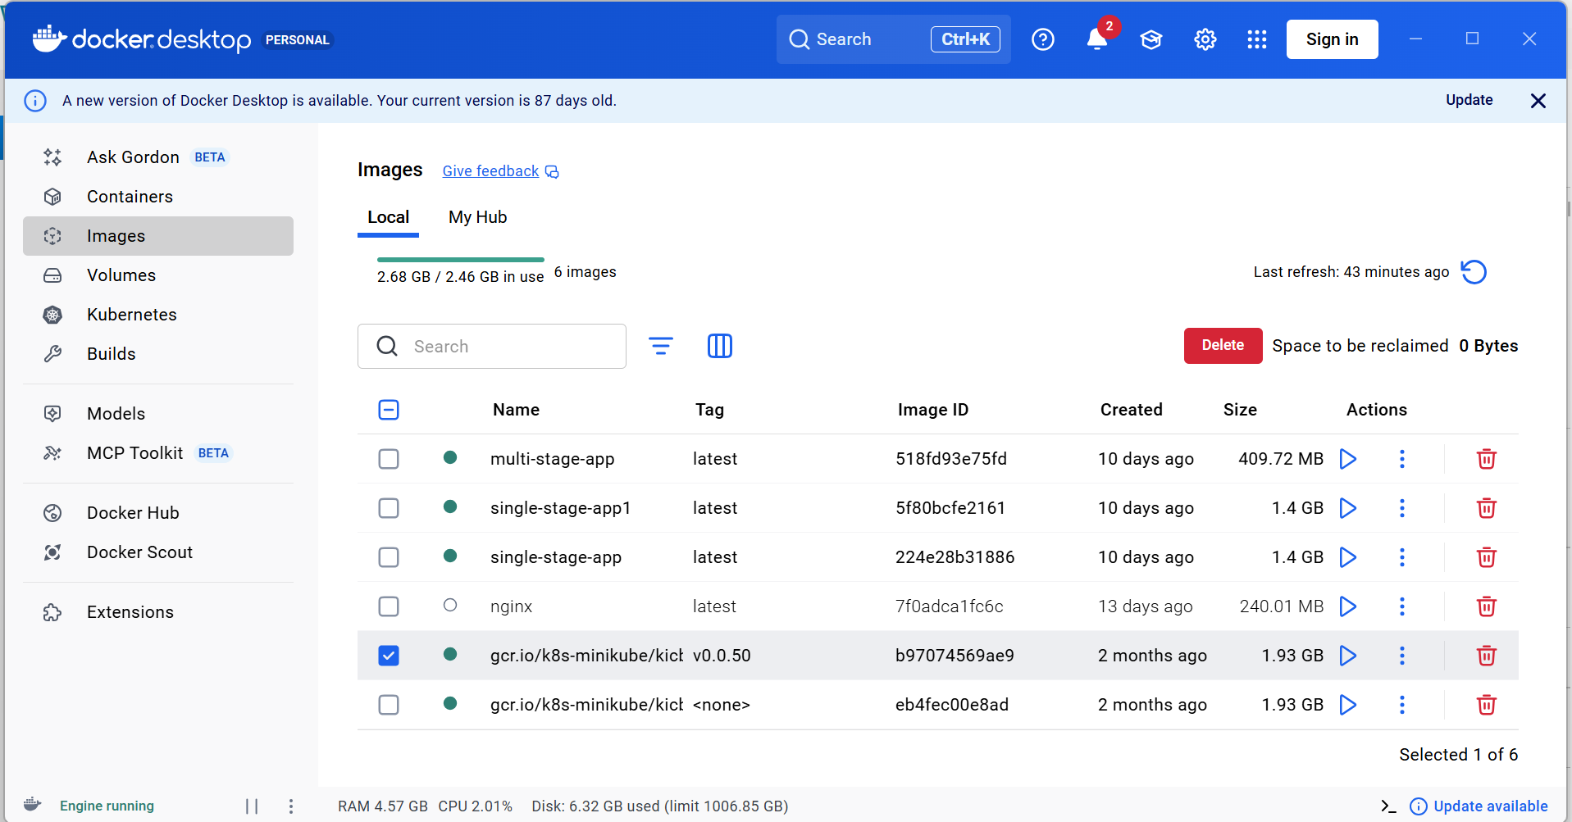
  - Install oracle virtual box
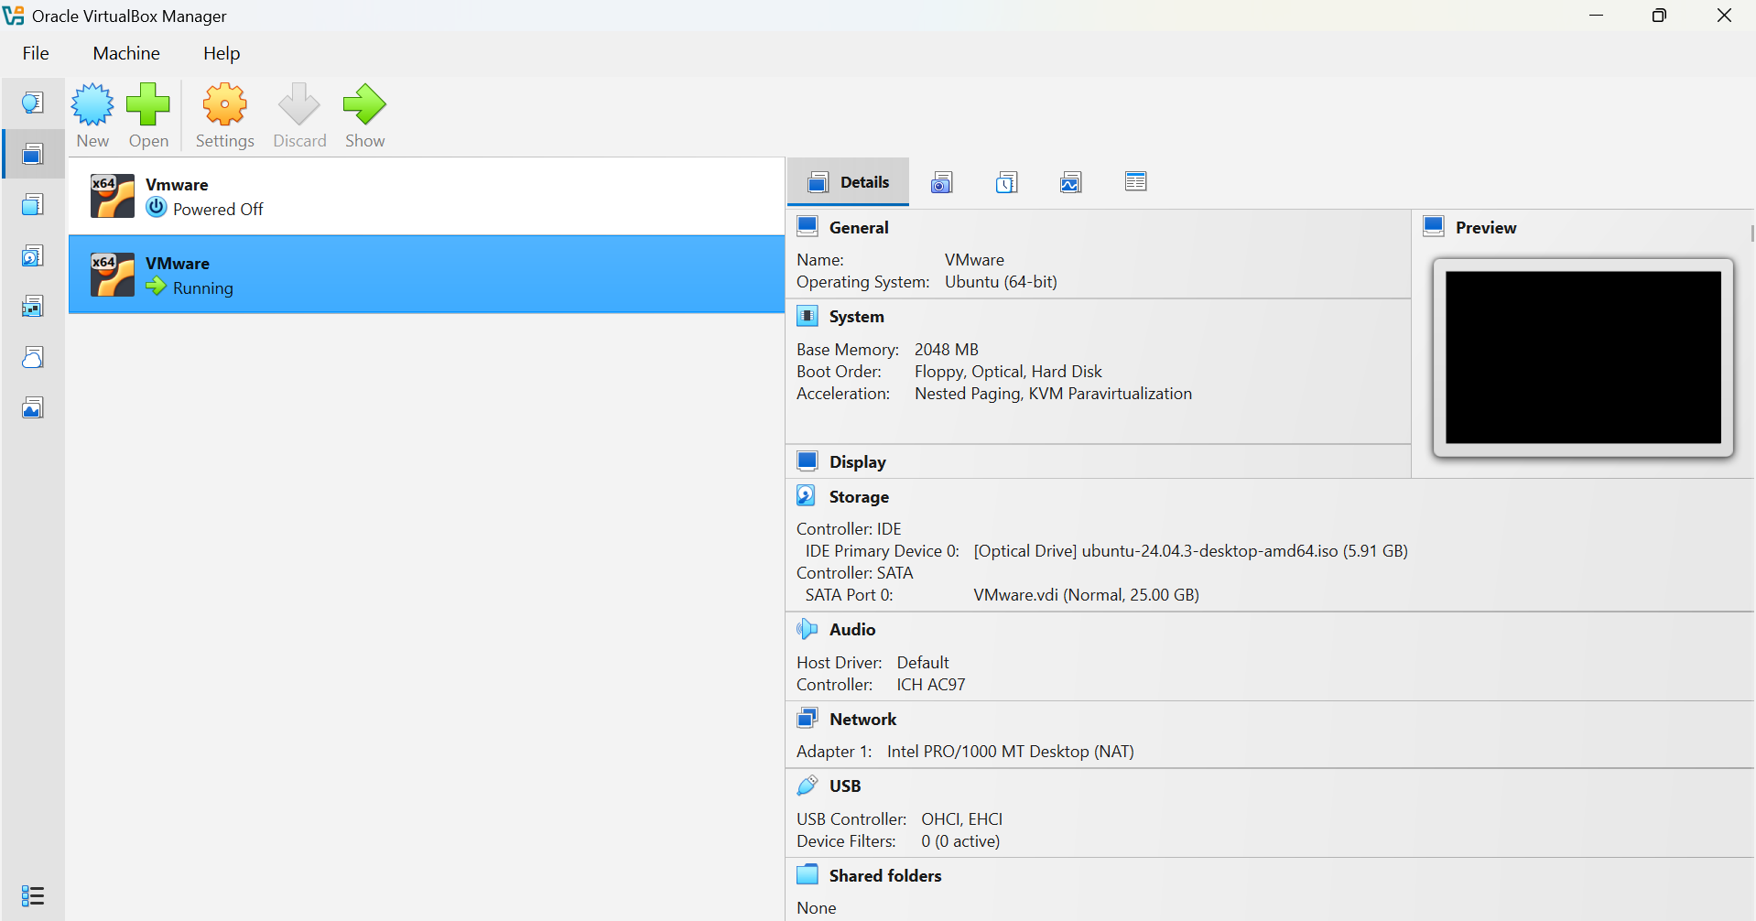

  - Check the CMD in windows
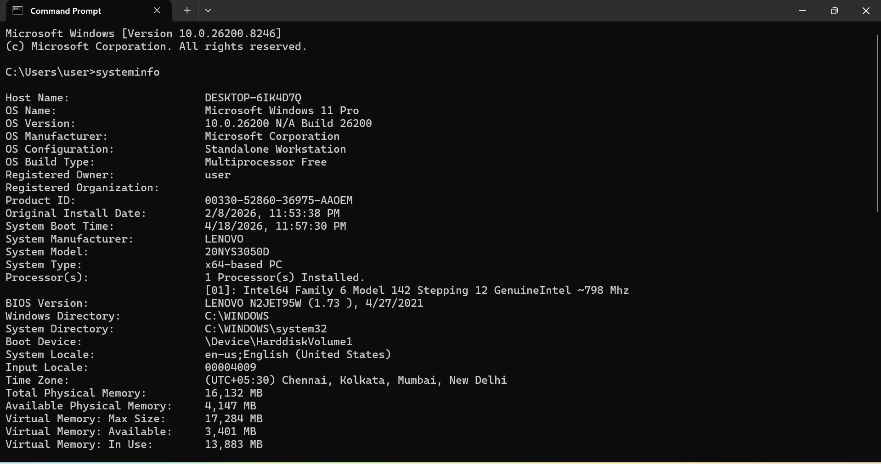
  - Search power shell in windows and open it
  - Install minikube using power shell hit the command
Start https://minikube.sigs.k8s.io/docs/start/
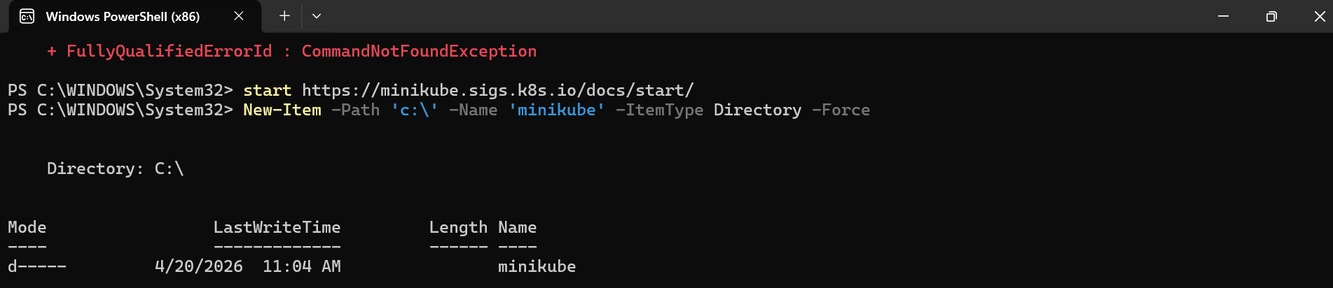
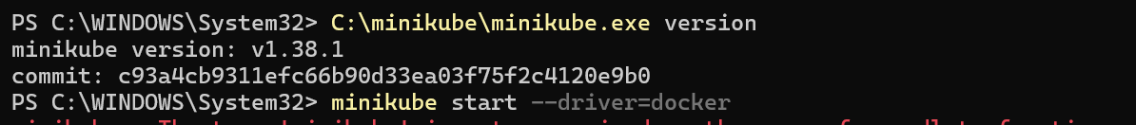
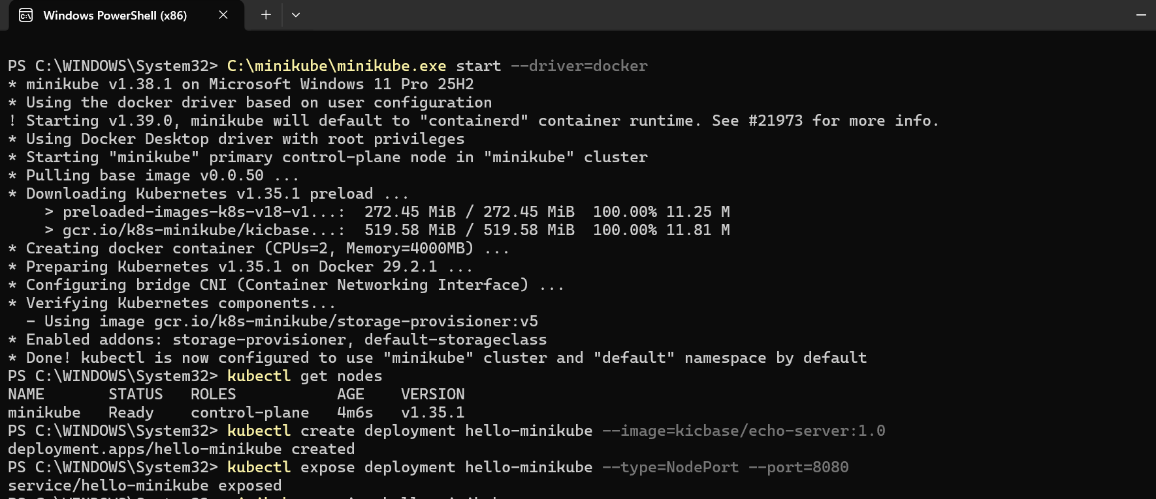
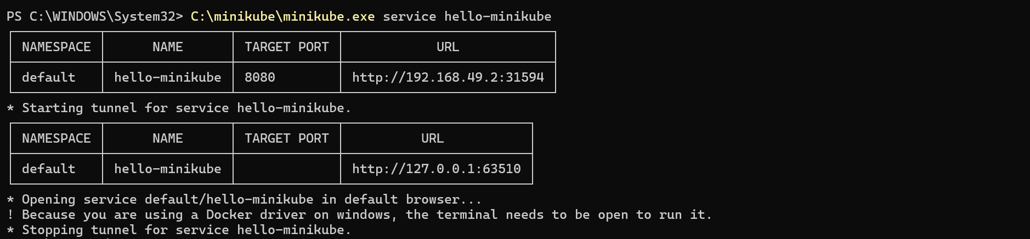

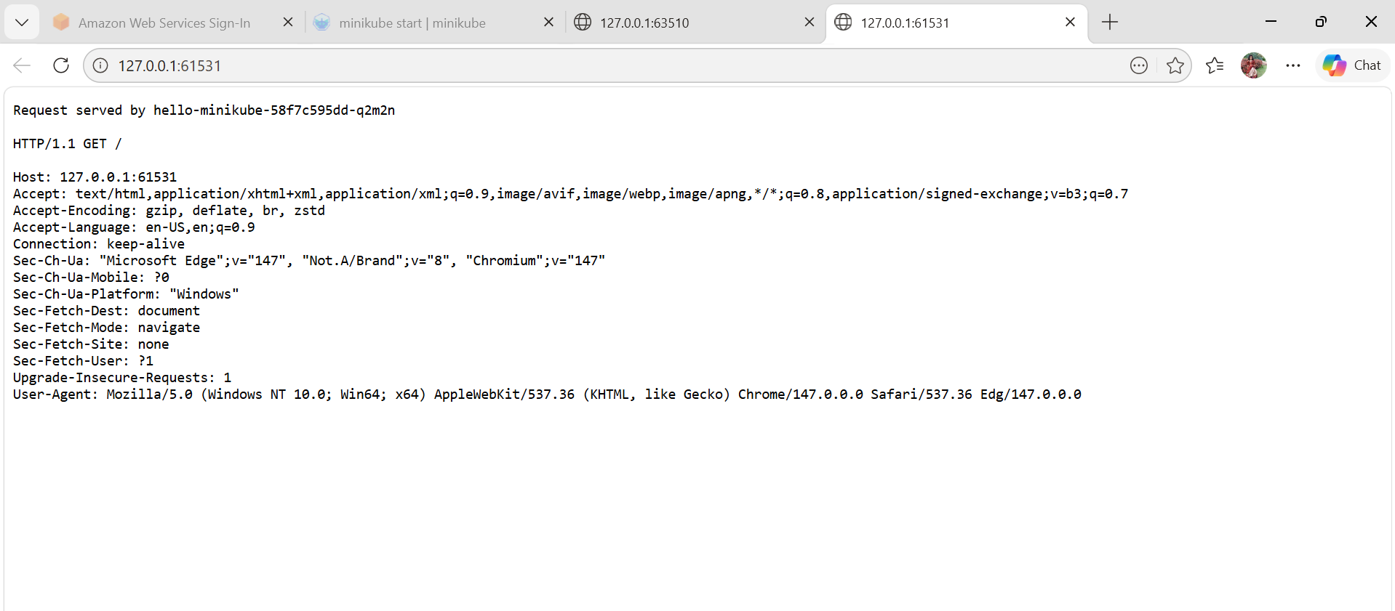

  - Set the minikube path to environment variable .
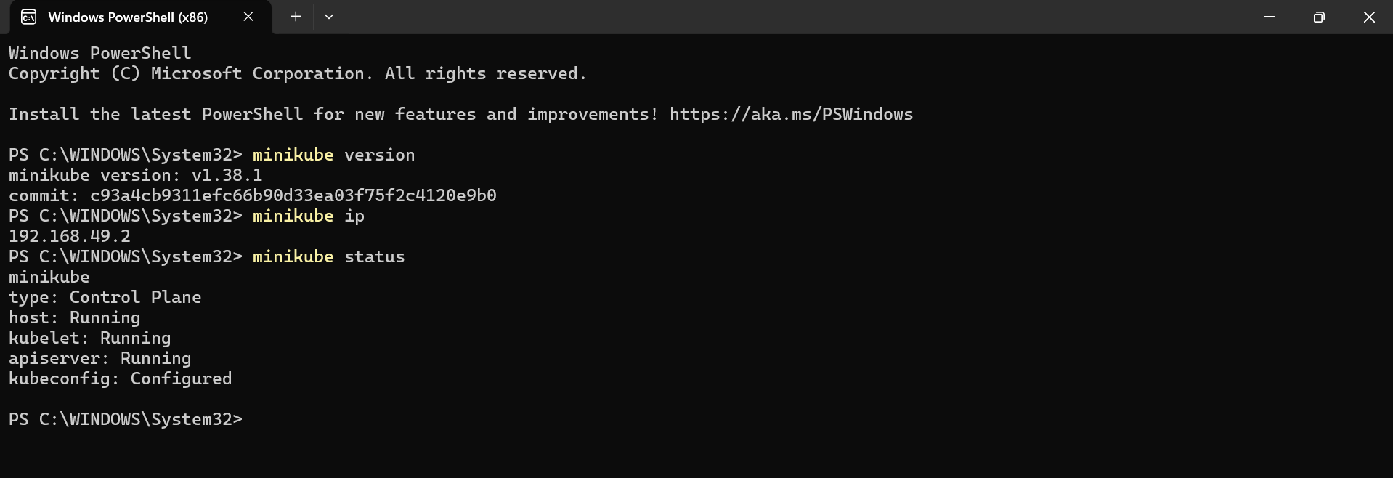
  - Restart power shell and start minikube
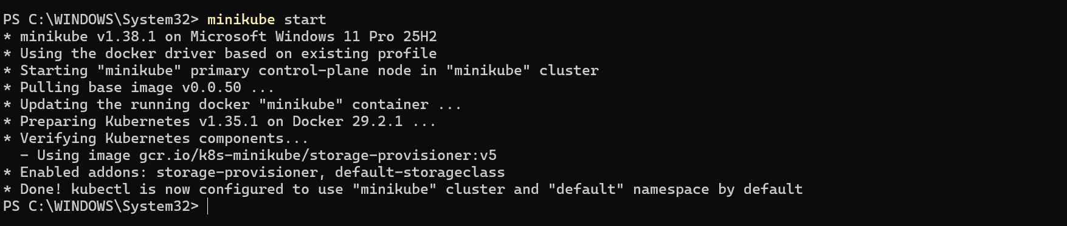
  - To check the minikube use below commands
Minikube ip
Minikube ssh
  - Afrer entering in minikube then logout using exit
Exit
Kubectl get pods
  - To see minikube on kubernetes dashboard using command
Minikube dashboard
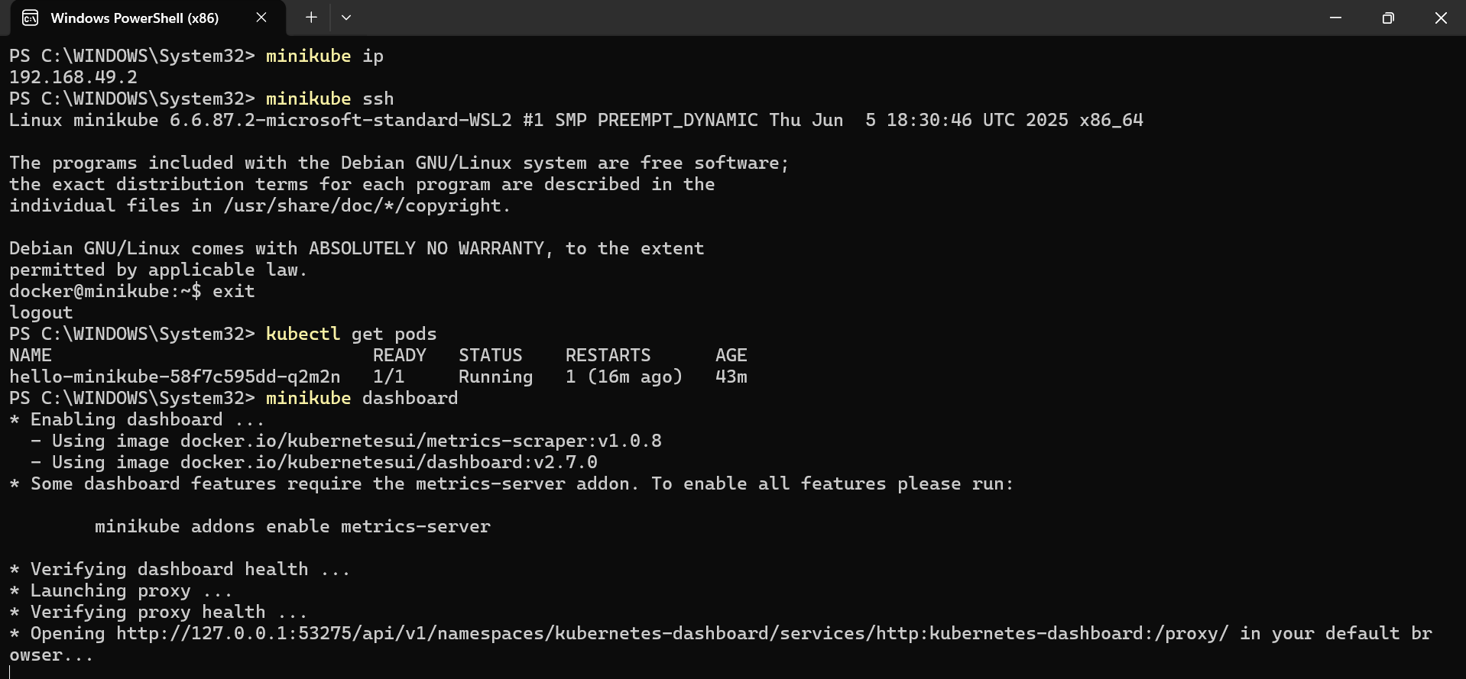
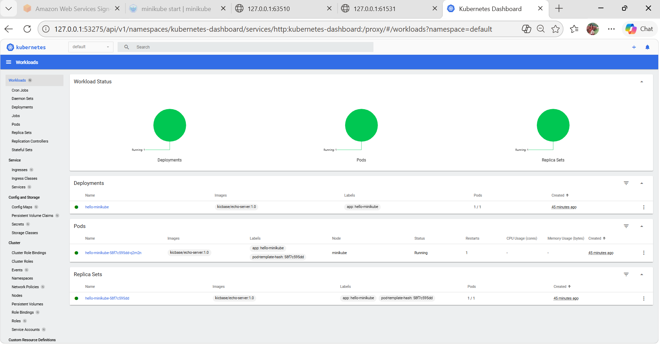
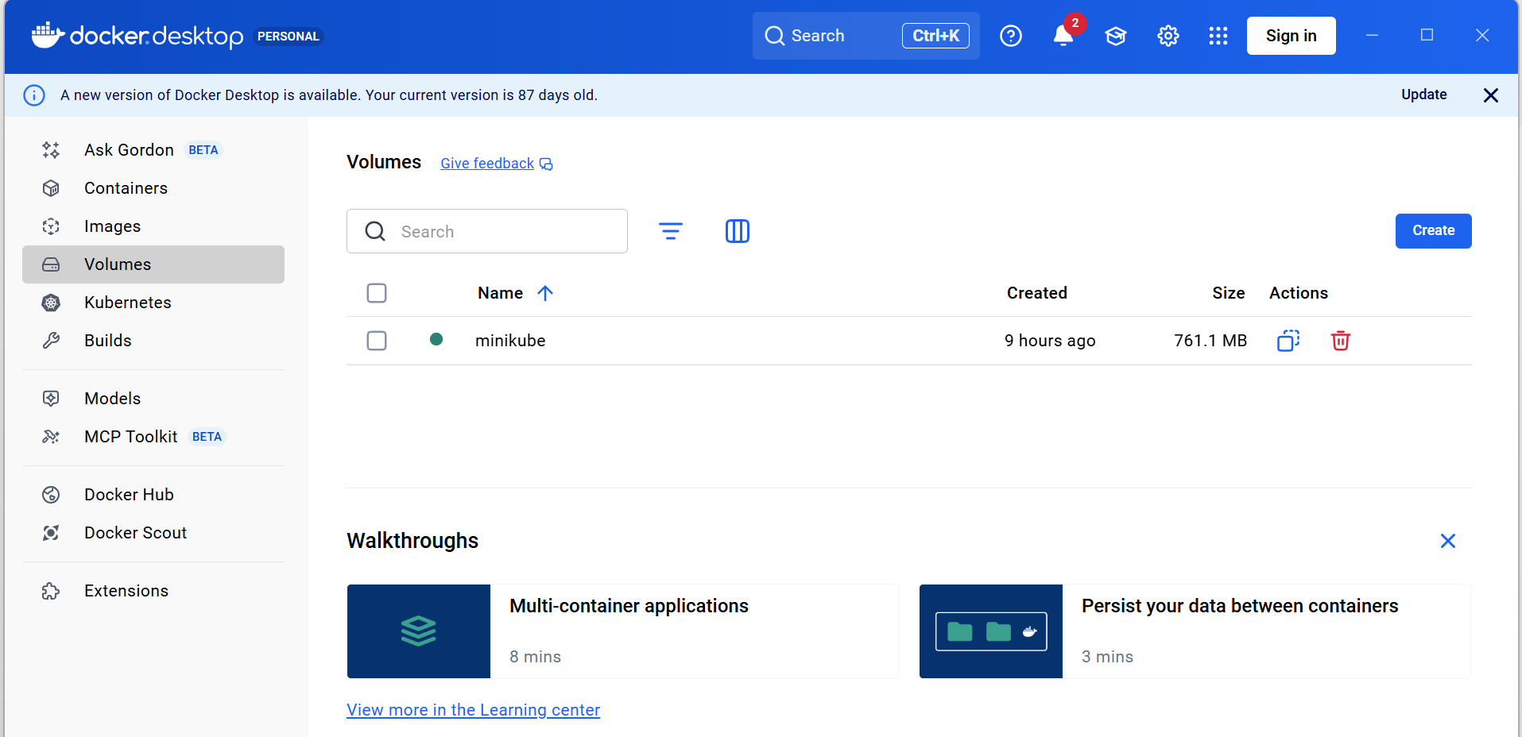
- Setup k8s master and two worker nodes on ubuntu.
  - Launch 3 instanes named k8s-master,worker-01,worker-02 with c71-flex.large instance type, with ebs 20 gb each.
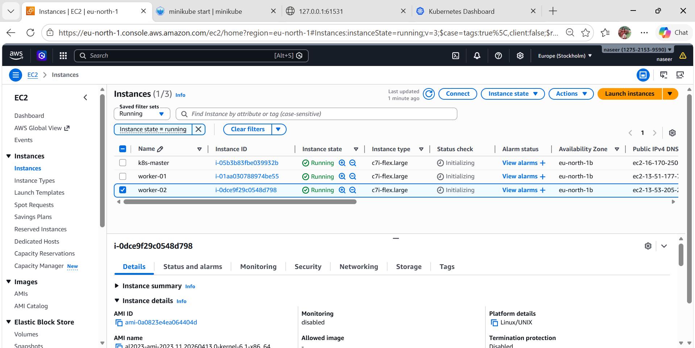
  - Set Hostnames (ALL NODES)
sudo hostnamectl set-hostname k8s-master # on master
sudo hostnamectl set-hostname k8s-worker1 # worker1
sudo hostnamectl set-hostname k8s-worker2 # worker2
  - Update /etc/hosts (ALL NODES)
Edit:
sudo nano /etc/hosts
Add:
<MASTER-IP> k8s-master
<WORKER1-IP> worker-01
<WORKER2-IP> worker-02

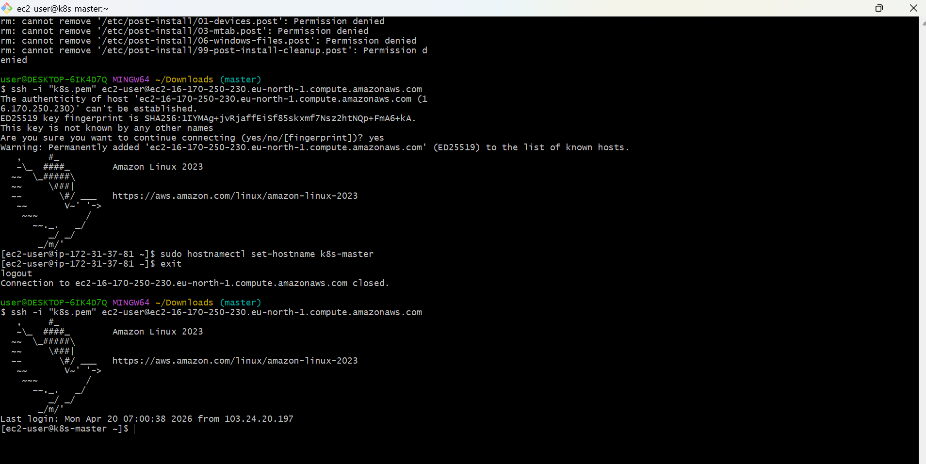
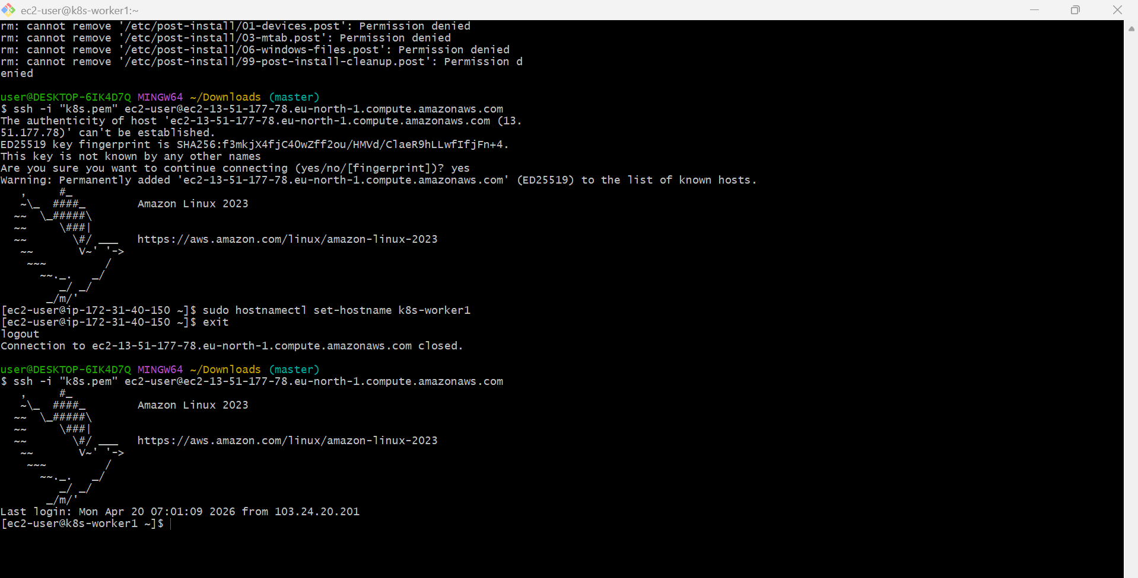

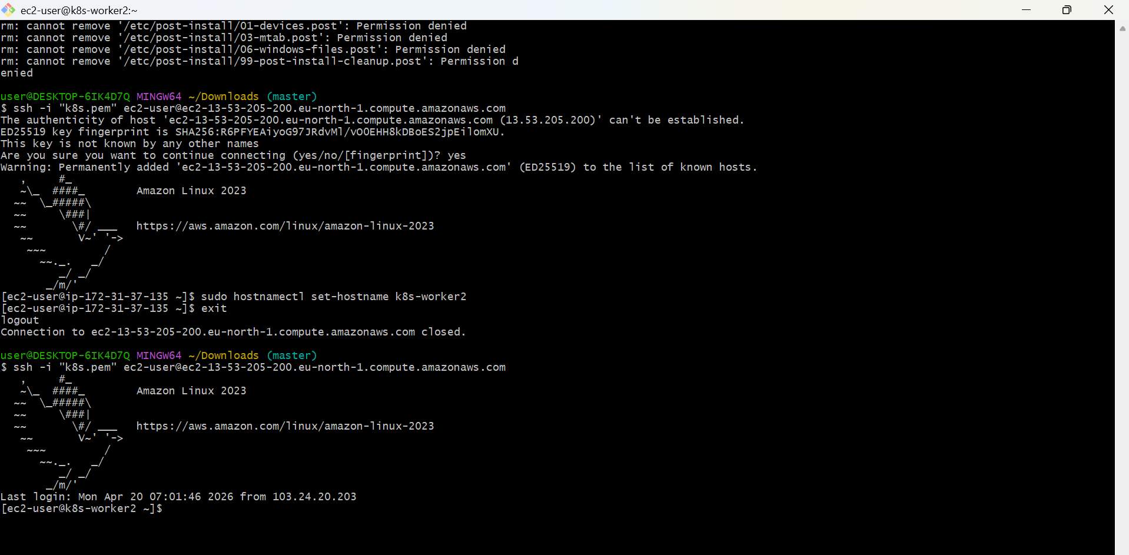
  - Excecute all below commands in master node and worker node as well.
  - Install Docker
    - yum -y install docker
    - docker –version
systemctl start docker
systemctl status docker
@ To setup k8s cluster we have different tools like kops and kubeadm. / Below mentioned the Google chrome installation path / After open the chrome page -> Select the OS type -> Like Redhat.
3.https://kubernetes.io/docs/setup/production-environment/tools/kubeadm/install-kubeadm/
4. sudo sed -i 's/^SELINUX=enforcing$/SELINUX=permissive/' /etc/selinux/config
5. vi /etc/yum.repos.d/kubernetes.repo
[kubernetes]
name=Kubernetes
baseurl=https://pkgs.k8s.io/core:/stable:/v1.29/rpm/
enabled=1
gpgcheck=1
gpgkey=https://pkgs.k8s.io/core:/stable:/v1.29/rpm/repodata/repomd.xml.key
exclude=kubelet kubeadm kubectl cri-tools kubernetes-cni
* For installation execute the below command
6. sudo yum install -y kubelet kubeadm kubectl --disableexcludes=kubernetes --disableplugin=priorities
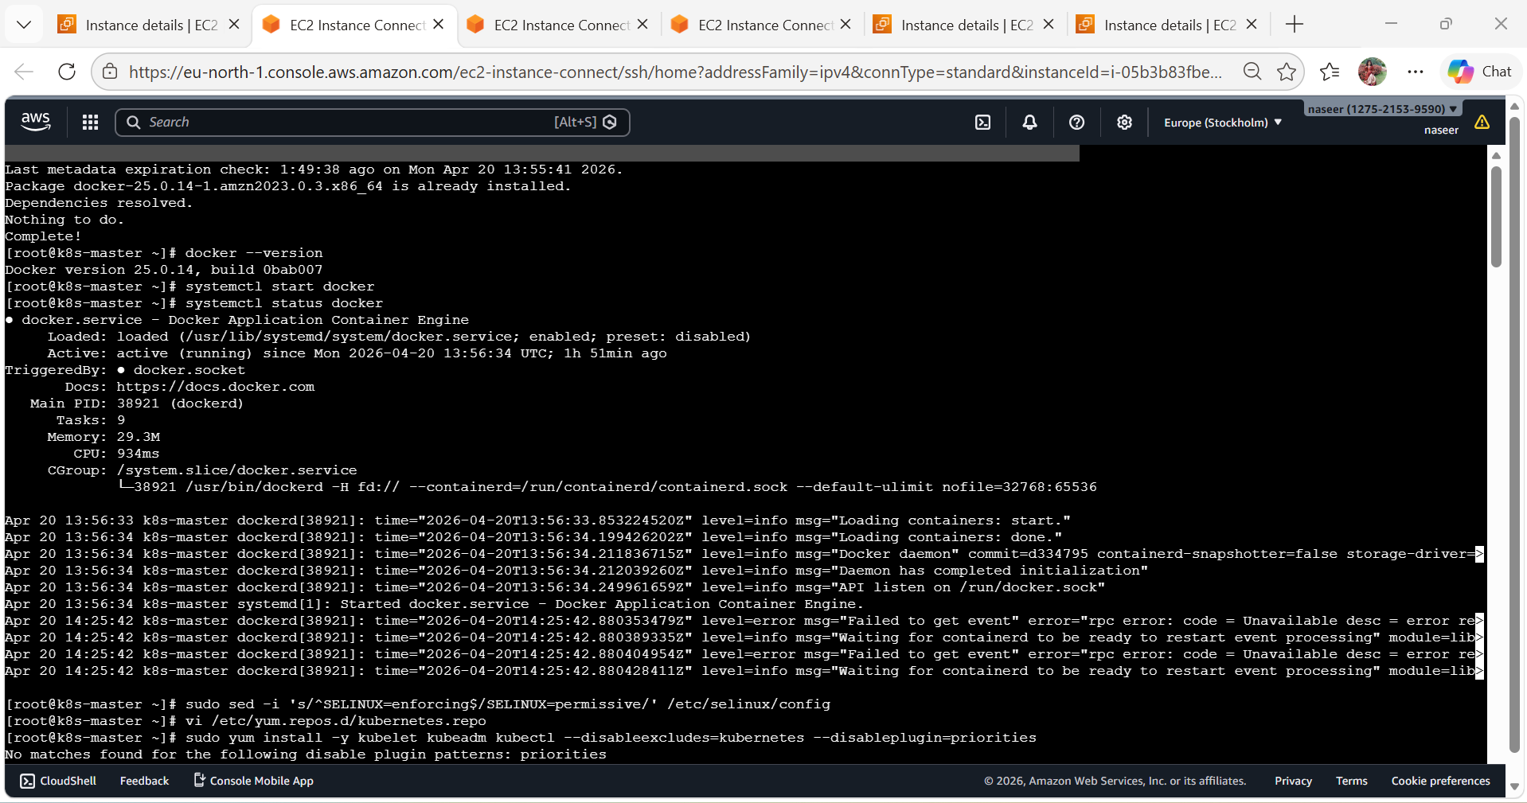
After executed Below command we will get some commands to execute / Mentioned Below
Note: Only master node will get the commands to execute in the workernodes
7. kubeadm init --pod-network-cidr=10.244.0.0/16
Note: We need to execute this command only in Master node

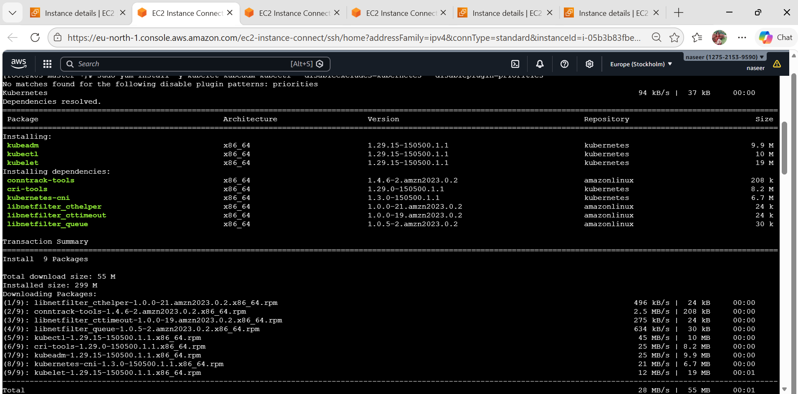
9. mkdir -p $HOME/.kube
10.sudo cp -i /etc/kubernetes/admin.conf $HOME/.kube/config
11.sudo chown $(id -u):$(id -g) $HOME/.kube/config
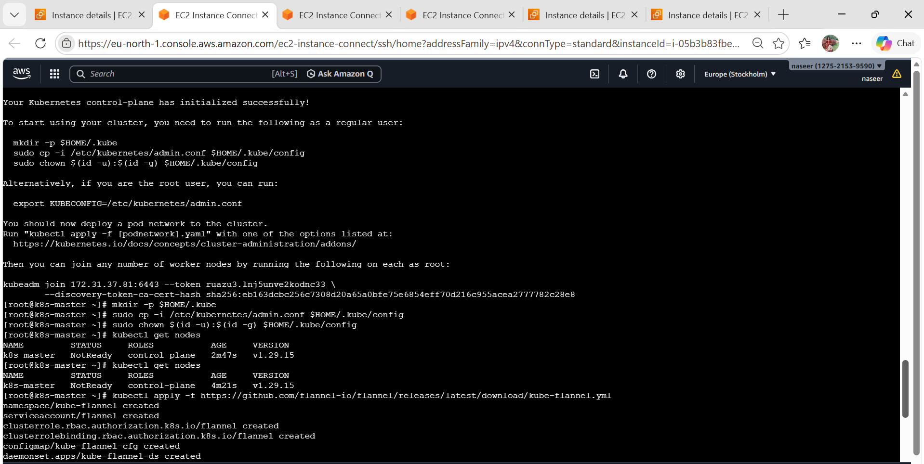
  - Execute this command in worker nodes.
kubeadm join 172.31.37.81:6443 --token ruazu3.lnj5unve2kodnc33 \
--discovery-token-ca-cert-hash sha256:eb163dcbc256c7308d20a65a0bfe75e6854eff70d216c955acea2777782c28e8

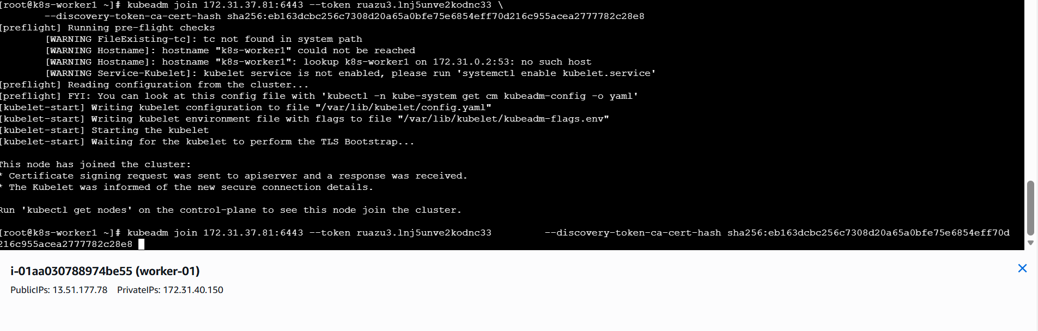

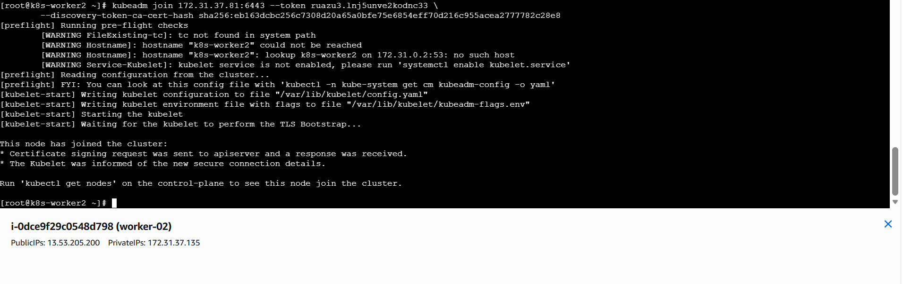
  - Execute this command in master nodes.
13. kubectl get nodes
Flannel is installed
kubectl apply -f https://github.com/flannel-io/flannel/releases/latest/download/kube-flannel.yml

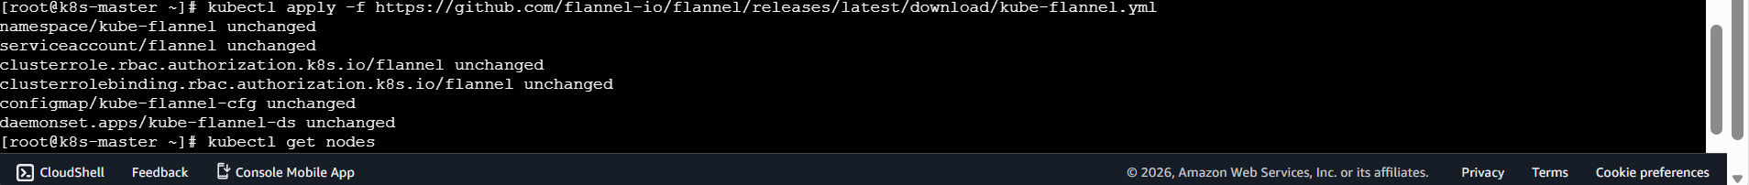

- Run one nginx pod.
  - Make sure cluster is ready
You need a running Kubernetes cluster (Minikube / K8s setup).
minikube start
  - Check cluster:
kubectl get nodes
  - Create NGINX Pod
kubectl run nginx-pod --image=nginx --restart=Never
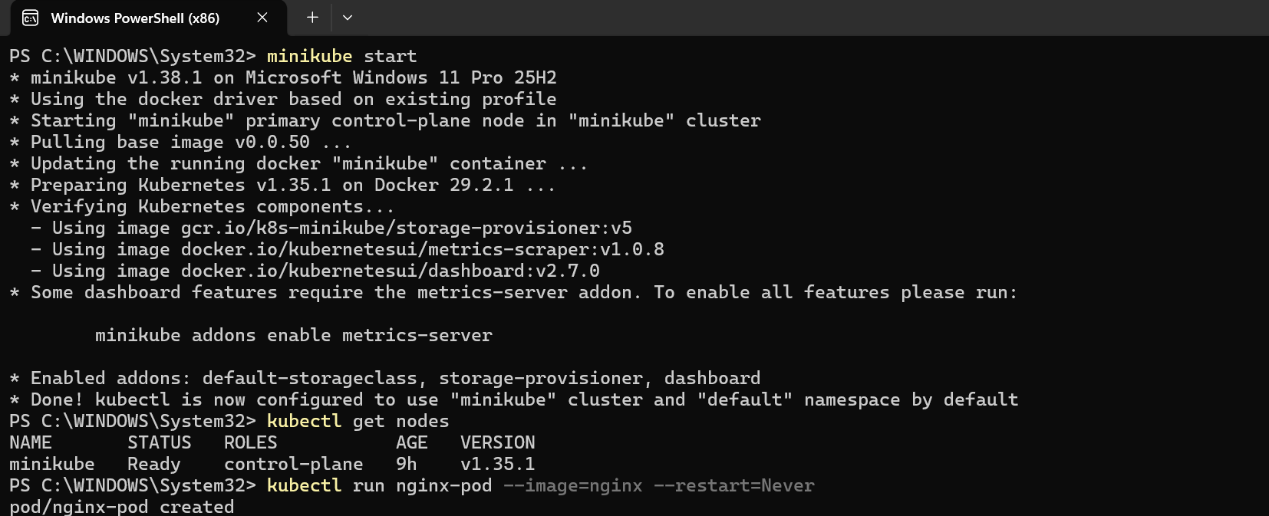

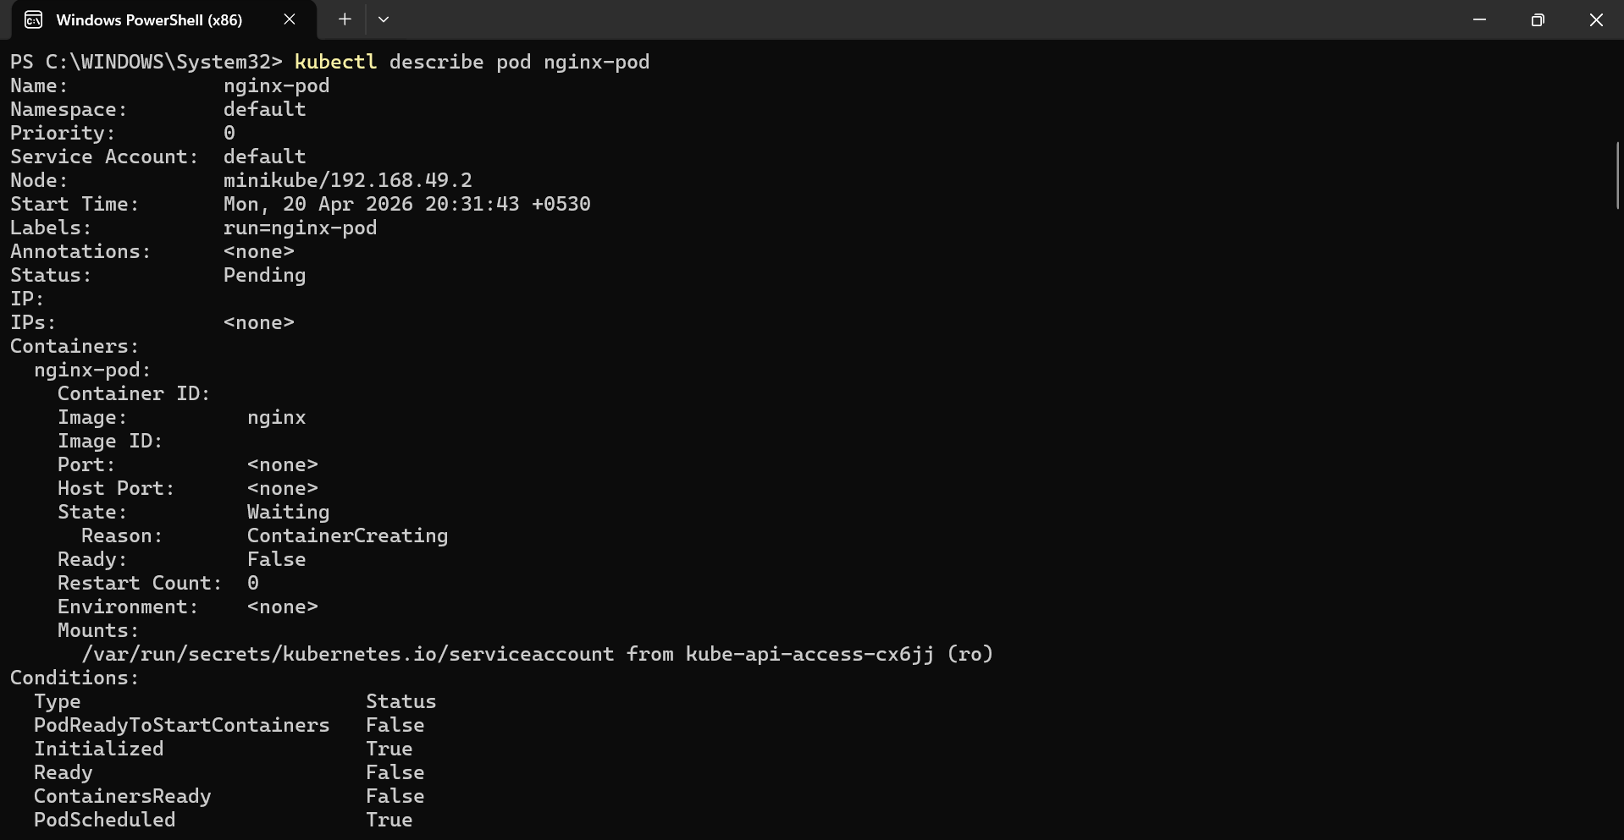
  - Verify Pod
kubectl get pods
  - Describe Pod
kubectl describe pod nginx-pod
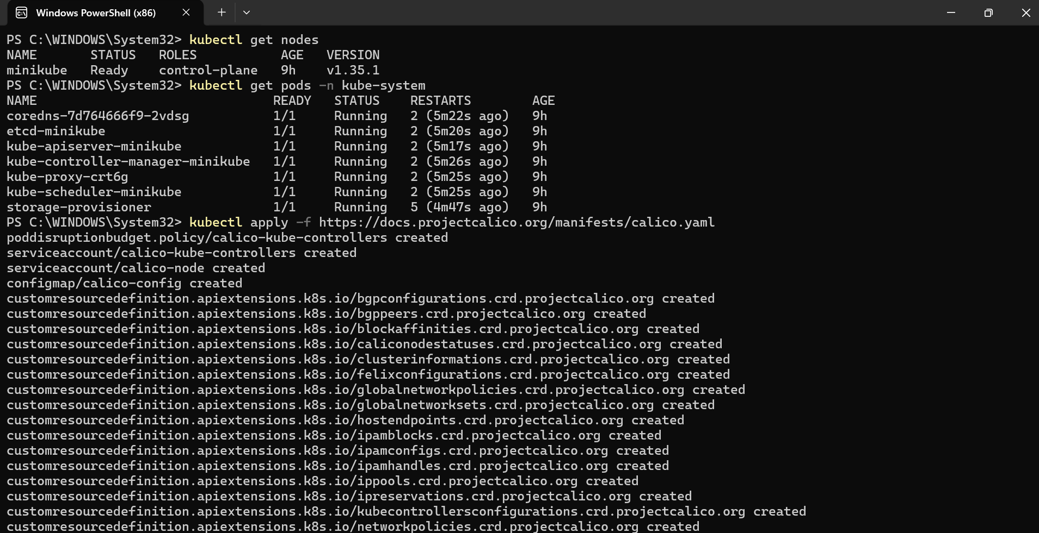
  - Check Logs
kubectl logs nginx-pod
  - Access NGINX
kubectl port-forward pod/nginx-pod 8080:80
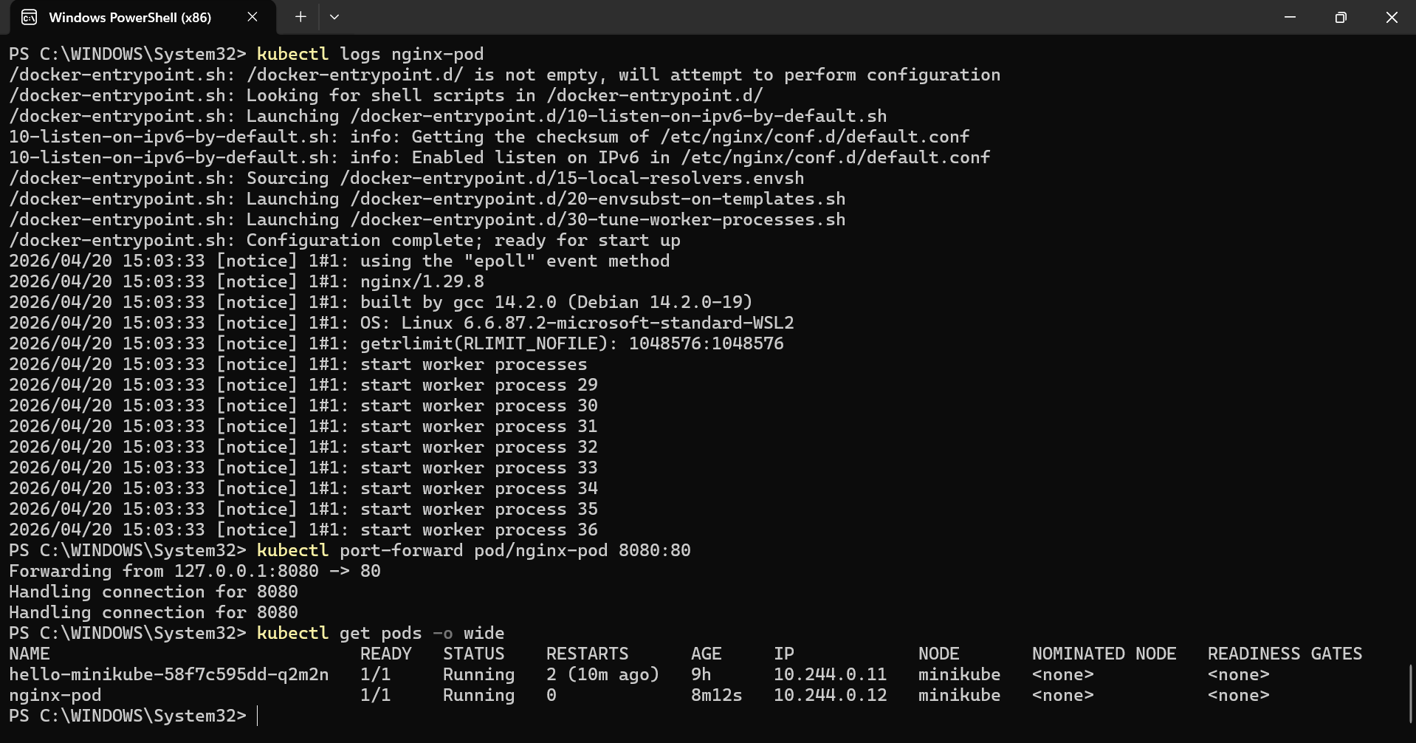
Now open browser:
http://127.0.01:8080
You’ll see NGINX welcome page
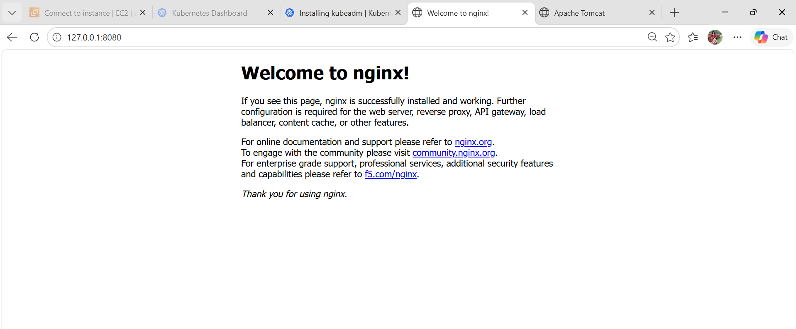

- Mugup Master and slave components on k8s.

